**Womanist Theology - The Cost of Being a Free Black Woman**

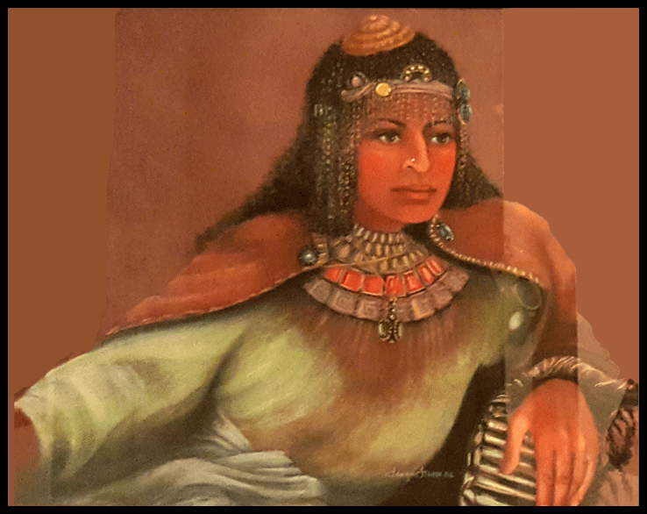

This initial chapter of the text whose main character is also the title of the book begins by presenting what would have been troubling for its original readers. The approval, validation and social authority of men would have been an overtly forgone conclusion and presents itself even in the Bible. Esther is the primary focus of her book, but Queen Vashti sets the stage for what becomes a dangerously tenuous environment for women. This in turn informs the current reader’s fear that Esther would express in 4.10-12. Again, it is probable that Queen Vashti would have been viewed by her modern-day audience not as courageous but asking for trouble. It is now, some 20 centuries later, that Queen Vashti is rediscovered, and her actions can be viewed positively. At its core, the male gaze that King Xerxes wanted to broaden for personal and political reasons should have been accepted without question in the mind of his advisors. The concern of the men is evident in verse 22. His assumed embarrassment while entertaining foreign military guests.

We as modern readers should take note that God is not mentioned at all in this initial story. Rather, it is the role that God provides for Esther, in light of the life-threatening perspective of the men she was surrounded by that shaped the social order. It is to share with us that there was and remains a culture that women have and do face that makes their stance to stand for anything – including God – dangerous if done in a manner that men do not sanction. It helps us to ask the question today, **what constraints do men fasten to society that impact the life of women who choose to stand for God?**

**Esther 1**

*1 These events happened in the days of King Xerxes, who reigned over 127 provinces stretching from India to Ethiopia. 2At that time Xerxes ruled his empire from his royal throne at the fortress of Susa. 3In the third year of his reign, he gave a banquet for all his nobles and officials. He invited all the military officers of Persia and Media as well as the princes and nobles of the provinces. 4The celebration lasted 180 days—a tremendous display of the opulent wealth of his empire and the pomp and splendor of his majesty.*

*5When it was all over, the king gave a banquet for all the people, from the greatest to the least, who were in the fortress of Susa. It lasted for seven days and was held in the courtyard of the palace garden. 6The courtyard was beautifully decorated with white cotton curtains and blue hangings, which were fastened with white linen cords and purple ribbons to silver rings embedded in marble pillars. Gold and silver couches stood on a mosaic pavement of porphyry, marble, mother-of-pearl, and other costly stones.*

*7Drinks were served in gold goblets of many designs, and there was an abundance of royal wine, reflecting the king’s generosity. 8By edict of the king, no limits were placed on the drinking, for the king had instructed all his palace officials to serve each man as much as he wanted.*

*9At the same time, Queen Vashti gave a banquet for the women in the royal palace of King Xerxes. 10On the seventh day of the feast, when King Xerxes was in high spirits because of the wine, he told the seven eunuchs who attended him—Mehuman, Biztha, Harbona, Bigtha, Abagtha, Zethar, and Carcas—11to bring Queen Vashti to him with the royal crown on her head. He wanted the nobles and all the other men to gaze on her beauty, for she was a very beautiful woman. 12But when they conveyed the king’s order to Queen Vashti, she refused to come. This made the king furious, and he burned with anger.*

**What environments does the male gaze and validating male authority still make life confining for women who choose to exist and act on the principle to not be exploited?**

*13He immediately consulted with his wise advisers, who knew all the Persian laws and customs, for he always asked their advice. 14The names of these men were Carshena, Shethar, Admatha, Tarshish, Meres, Marsena, and Memucan—seven nobles of Persia and Media. They met with the king regularly and held the highest positions in the empire.*

*15“What must be done to Queen Vashti?” the king demanded. “What penalty does the law provide for a queen who refuses to obey the king’s orders, properly sent through his eunuchs?”*

*16Memucan answered the king and his nobles, “Queen Vashti has wronged not only the king but also every noble and citizen throughout your empire. 17Women everywhere will begin to despise their husbands when they learn that Queen Vashti has refused to appear before the king.*

*18Before this day is out, the wives of all the king’s nobles throughout Persia and Media will hear* *what the queen did and will start treating their husbands the same way. There will be no end to their contempt and anger.*

*19“So if it please the king, we suggest that you issue a written decree, a law of the Persians and Medes that cannot be revoked. It should order that Queen Vashti be forever banished from the presence of King Xerxes, and that the king should choose another queen more worthy than she. 20When this decree is published throughout the king’s vast empire, husbands everywhere, whatever their rank, will receive proper respect from their wives!”*

*21The king and his nobles thought this made good sense, so he followed Memucan’s counsel. 22He sent letters to all parts of the empire, to each province in its own script and language, proclaiming that every man should be the ruler of his own home and should say whatever he pleases.* [1]

Let us not confuse the lack of God-talk in this first chapter to make us dismiss the fact that the author thought it essential to include this story in a woman’s (Esther’s) account who make a decision to stand not only for God but for God’s people.

**Is the Christian Church today truly a community of liberated people if we can only think according to our principles but cannot openly live by them? Explain your answer below.**

**Ecclesiology - Liberation in Jesus**

The space that the Christian Church allows and encourages for women to exist in is important to not only consider but be intentional about setting. Any place and people, including the Christian Church, that attempts to reduce the equal place of women in society and especially in the church is practicing oppression. Jesus is a liberating savior; therefore, his salvific work is not only a move of equality but equity. That which governs the Church does not place justice for all in the hands of one gender. The Word of God provides a means of understanding how we as today’s church are required to provide equity to confirm equality. To be clear, equality is the state of having “the same measure, quantity, amount, or number as another.”[2]

Equity is “justice according to natural law or right.”[3] That is to suggest that spiritual faith must also be a practiced, practical faith. If liberation comes through Christ, as it does, then we cannot create communities of repression based on our social proclivities, no matter how common those proclivities may be in modern society.

**Galatians 3.19-29**

*19Why, then, was the law given? It was given alongside the promise to show people their sins. But the law was designed to last only until the coming of the child who was promised. God gave his law through angels to Moses, who was the mediator between God and the people. 20Now a mediator is helpful if more than one party must reach an agreement. But God, who is one, did not use a mediator when he gave his promise to Abraham.*

**What is the standard that “mediators” in the church must ultimately follow to settle disputes?**

*21Is there a conflict, then, between God’s law and God’s promises? Absolutely not! If the law could give us new life, we could be made right with God by obeying it. 22But the Scriptures declare that we are all prisoners of sin, so we receive God’s promise of freedom only by believing in Jesus Christ. 23Before the way of faith in Christ was available to us, we were placed under guard by the law. We were kept in protective custody, so to speak, until the way of faith was revealed.*

*24Let me put it another way. The law was our guardian until Christ came; it protected us until we could be made right with God through faith. 25And now that the way of faith has come, we no longer need the law as our guardian.*

**What does the writer mean when the Scripture says that Christians “no longer need the law as our guardian?”**

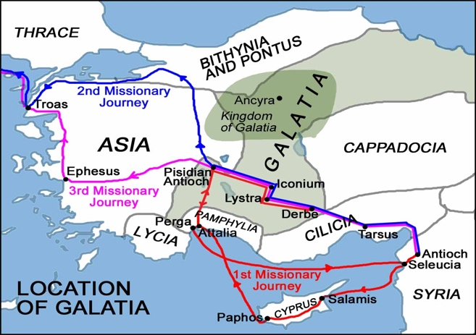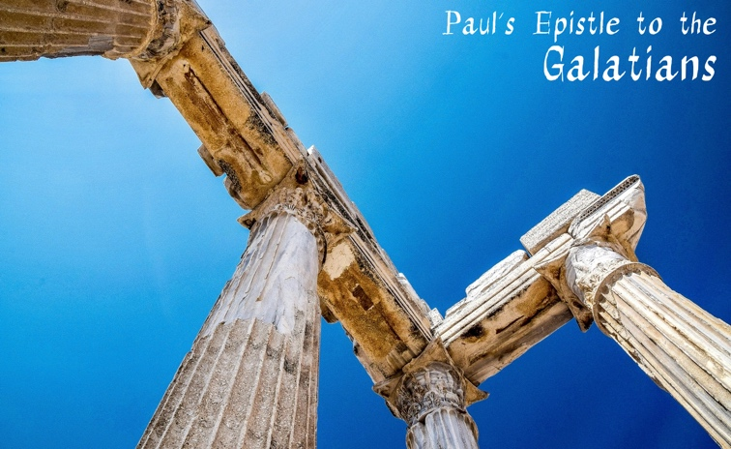

*26For you are all children of God through faith in Christ Jesus. 27And all who have been united with Christ in baptism have put on Christ, like putting on new clothes. 28There is no longer Jew or Gentile, slave or free, male and female. For you are all one in Christ Jesus. 29And now that you belong to Christ, you are the true children of Abraham. You are his heirs, and God’s promise to Abraham belongs to you.* [4]

**What is verse 27 & 28 suggesting about the identity of people who have become Christians?**

Ultimately, Scripture is concerned with the relationship of the believer with God through Christ. The bridegroom (God) is looking forward to a prepared bride (the Church). It may be assumed that the Preparer of the Church for God is Christ, inasmuch as the marriage of the Church and God is the joining of the two without mystery nor distance of identity. The identity of God as Spirit[5] prepares the Church to exist with the Spirit of God through its transformational relationship with Christ. Consistent reminders, teachers, prophets and angels come to us in order to help us become the Church Triumphant that can live victorious in Christ – not a small numbered group, but an innumerable crowd of believers.

**Eschatology - The Preparation of the Bride: Revelation 19.1-8**

1 After this, I heard what sounded like a vast crowd in heaven shouting,

“Praise the Lord!

Salvation and glory and power belong to our God.

2His judgments are true and just.

He has punished the great prostitute

who corrupted the earth with her immorality.

He has avenged the murder of his servants.”

3And again their voices rang out:

“Praise the Lord!

The smoke from that city ascends forever and ever!”

4Then the twenty-four elders and the four living beings fell down and worshiped God, who was sitting on the throne. They cried out, “Amen! Praise the Lord!”

5And from the throne came a voice that said,

“Praise our God,

all his servants,

all who fear him,

from the least to the greatest.”

6Then I heard again what sounded like the shout of a vast crowd or the roar of mighty ocean waves or the crash of loud thunder:

“Praise the Lord!

For the Lord our God, the Almighty, reigns.

7Let us be glad and rejoice,

and let us give honor to him.

For the time has come for the wedding feast of the Lamb,

and his bride has prepared herself.

8She has been given the finest of pure white linen to wear.”

For the fine linen represents the good deeds of God’s holy people. [6]

**Who must the Church become in order to live victoriously?**

1. Tyndale House Publishers, [*Holy Bible: New Living Translation*](https://ref.ly/logosres/nlt?ref=BibleNLT.Es1.1&off=19&ctx=%0aThe+King%E2%80%99s+Banquet%0a~These+events+happene) (Carol Stream, IL: Tyndale House Publishers, 2015), Es 1:1–22.
2. https://www.merriam-webster.com/dictionary/equal
3. https://www.merriam-webster.com/dictionary/equity
4. Tyndale House Publishers, [*Holy Bible: New Living Translation*](https://ref.ly/logosres/nlt?ref=BibleNLT.Ga3.19&off=0&ctx=ham+%E2%80%A2as+a+promise.+%0a~19%C2%A0Why%2c+then%2c+was+th) (Carol Stream, IL: Tyndale House Publishers, 2015), Ga 3:19–29.
5. John 4.24 “For God is Spirit, so those who worship him must worship in spirit and in truth.”
6. Tyndale House Publishers, [*Holy Bible: New Living Translation*](https://ref.ly/logosres/nlt?ref=BibleNLT.Re19.1&off=27&ctx=f+Victory+in+Heaven%0a~After+this%2c+I+heard+) (Carol Stream, IL: Tyndale House Publishers, 2015), Re 19:1–8.